November 27th, 2011
Hi
I had quite a good run yesterday; better conditions than last week, with temperatures at about 21⁰C and dry. Ran in the same area as last week (but around the other side of the reservoir which has a paved road). At 2 h 11 min it was 2 minutes faster than last year; not the fastest or the slowest for this route but still good. Interestingly, the best leg was just after halfway when some runners passed me and 'pulled' me along for a bit, so I was 1 or 2 minutes faster for this leg than any previous time.
Yesterday, there was a general election in NZ. I did not know about this until 2 or 3 days ago when it was mentioned on Aus TV. The current party (led by a former Burnside HS student, who was at the 50th jubilee last year) was returned to power with an increased majority, but one short of an absolute majority. Since 1998(?), NZ has had a partly proportional representation system so there has always been coalition governments. As in many countries, there are the geographical constituencies with one person elected in a 'first past the post' system. But each party also has a list of additional people (as many on the list as they want) and they get a certain number of members from the list for parliament according to the total proportion of the total votes that party gets in all the geographical constituencies.

Last week I decided to do lighter workouts in the gym for some time to 'recover' from all the hard work in the past 11 months or so. On the way back from the gym one day, I picked up a free bottle of Lee Kum Kee Soy Sauce from a company van on the side of the road that was promoting it. You may have heard of this sauce. As I don't use it myself, I gave it away.
The government in HK has announced that it is to give or 4 or 5 days of paternity leave to civil servants. Yesterday, one of the candidates for next year's Chief Executive announced officially that he was actually standing. Another will do this in the next few days. Everybody knew they were standing. The CE is chosen by just 1200 people (up from 800 five years ago for the previous CE election). However, for the next election in 5 years time, the CE is to be chosen by universal suffrage followed by the legislature in 2020.
On 60 Minutes the other night, there was Andy Rooney looking hale and hearty! We certainly must get the programme a long time after you do.
Did you know that there is a relation between smelly socks and malaria? Apparently, the mosquitoes are strongly attracted to the odour produced. So smelly socks are set up inside traps to attract and kill them. For more, here is one website:
http://www.medicalnewstoday.com/articles/231033.php

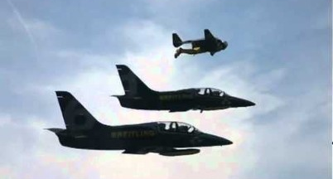
Did you see the pics of the Swiss 'Jet Man' flying in formation with two jets above the Swiss Alps? He did this the other day. Very interesting. Two videos:
http://www.youtube.com/watch?v=h4arnATc04U
https://plus.google.com/103928549898366062378/posts/jc7f66KDzQS
That’s about it for now.
Cheers

